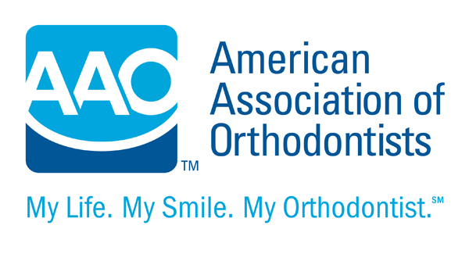
THIS IS A SUPPLEMENTAL INFORMED CONSENT
Informed Consent for an Impacted Tooth or Teeth

Your orthodontist has determined that one or more of your permanent teeth has not grown into the mouth normally. A tooth that is trapped within the surrounding bone is called “impacted”. In most cases, impacted teeth can be successfully aligned. However, you should be aware that any of the following situations might arise:

- Your orthodontist might recommend additional diagnostic studies (special radiographic scans, etc.) to help determine the exact position of the impacted tooth and the surrounding teeth.
- Additional diagnostic studies may be necessary during orthodontic treatment to determine the position and condition of the involved teeth.
- In order to align an impacted tooth, a referral might be made to an oral surgeon or a periodontist (dental specialist who treats gum problems) to have the impacted tooth or teeth uncovered and/or a temporary attachment placed on the tooth or teeth. The fees for services performed by other specialists are separate and additional to the orthodontic treatment fees.
- If such a referral is made, you should speak with the specialist about other possible risks and limitations of this procedure:________________________________________________________________________________
- There is a possibility that if a temporary attachment is placed on the impacted tooth or teeth, it might detach
during orthodontic treatment. The oral surgeon or periodontist might have to replace it. This might require a
second surgical procedure.
- In rare cases, an impacted tooth might be fused to the surrounding bone (ankylosis) and might not move with orthodontics. If so, tooth removal might be necessary. In some cases, the space might be closed with additional orthodontic treatment after the ankylosed tooth is surgically removed. In other cases, the ankylosed tooth may need to be surgically removed and replaced by your dentist. The additional costs for tooth replacement are separate from the fee for your orthodontic treatment.
- An impacted tooth might have caused damage to adjacent teeth that is not evident until the tooth or teeth are moved. Additionally, if an impacted tooth is moved, it might push against the roots of the adjacent teeth and damage them. This complication might be unavoidable because of the position of the impacted tooth. The root of the impacted tooth might also shorten during movement. In severe cases, one or more teeth might be lost due to root shortening.
- During movement of an impacted tooth, the nerve of the impacted tooth or of the adjacent teeth might be damaged. This occurrence might be unavoidable because of the position of the impacted tooth. Root canal treatment might be necessary. The cost of root canal treatment is separate and in addition to the orthodontic fee.
- If the impacted tooth is brought into alignment, it might become evident that the tooth is a different shape or color than the adjacent teeth. You might choose to ask your general dentist to provide cosmetic correction. The cost of cosmetic correction of a tooth or teeth is separate and additional to the orthodontic fee.
- When the alignment of the impacted tooth is complete, the gum line along the formerly impacted tooth and the adjacent teeth might be uneven. Impacted teeth often experience some gum recession during alignment. If the appearance of the gum line can be improved, the service of another dental specialist may be required, the cost of which is separate and additional to the orthodontic fee.
Additional comments _____________________________________________________________________________
________________________________________________________________________________________________
________________________________________________________________________________________________

Patient/Parent_____________________________________________Date__________________

Orthodontist_______________________________________________Date__________________

