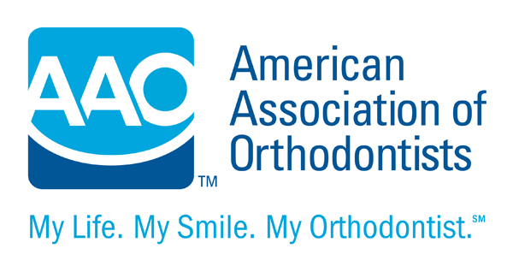
THIS IS A SUPPLEMENTAL INFORMED CONSENT

Informed Consent for Patients with Periodontal Concerns

Your orthodontist has determined that you might be at risk for periodontal (gum) disease. You should be aware that the health of your teeth and gums might affect the outcome of your orthodontic treatment.

Periodontal diseases are serious bacterial infections that destroy the attachment fibers and supporting bone that hold your teeth in your mouth. These diseases can lead to tooth loss.

During your orthodontic treatment, you must continue your regular visits to your periodontist or general dentist. Your periodontist or general dentist will supervise the health of your teeth and gums. It’s essential that you follow your periodontist’s or general dentist’s instructions on oral hygiene, medications and return appointments. If you fail to follow your periodontist’s or general dentist’s instructions, you risk losing one or more teeth.

Although the chief cause of periodontal disease is bacteria that attack the gums and bone, there are other factors that can cause periodontal disease to worsen. Tobacco in any form makes your gums much more prone to periodontal disease. You should not smoke or chew tobacco while undergoing orthodontic treatment. Stress, poor diet and genetics have also been linked to periodontal disease.

Periodontal disease can interfere with normal tooth movement. If you have uncontrolled periodontal disease, your teeth might not move on schedule, and/or they might return to their former position after orthodontic treatment is completed.

If your periodontal disease is not controlled, your gums are prone to localized infections (periodontal abscesses) that are very destructive to the underlying bone. You might be prescribed antibiotics to take by mouth and/or apply to the infected area.

Fixed appliances (braces) make thorough brushing and flossing more challenging. Your orthodontist might recommend additional oral hygiene aids (electric toothbrush, flossing aids, mouthrinses) to improve the health of your gums. Your orthodontist might recommend periodic x-rays or other diagnostic studies to monitor the health of your gums.

Periodontal disease can be very difficult to control. It is possible that even if you follow all the recommendations of your dentists, your periodontal disease might worsen during or after orthodontic treatment. In the worst case, you might lose one or more teeth to periodontal disease.

Additional comments
__________________________________________________________________________________________
____________________________________________________________________________________________________________________________________________________________________________________

Parent/Patient________________________________________Date_________________

Orthodontist__________________________________________Date_________________

