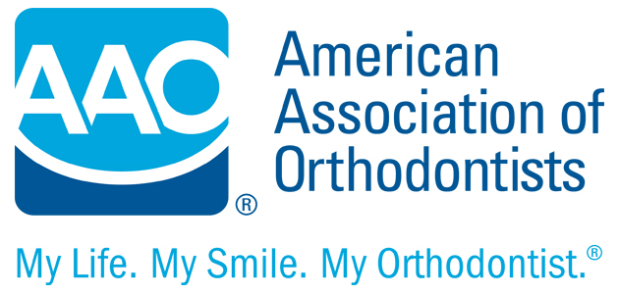

Supplemental Orthodontic History Questionnaire

Date

Patient’s Name

On your health history you have identified your child with

Would you please help us understand more about this condition and how it might affect your child in a dental/orthodontic setting?

- Could you tell us about the condition your child had and how it affects behavior.

- Please describe any significant fears or anxieties that your child may experience during visits to health care professionals (including dental).

- Has the anxiety or fear prevented any necessary treatment? Please describe.

- Are there any strategies that help your child open up to new experiences such as a visit to a new doctor (Examples: show and tell, humor, going very slowly; modeling with parent or other sibling, other examples)?

- Are there physical disabilities that need to be taken into consideration? (Examples: Difficulty with fine motor skills)

- How does your child deal with physical discomfort?

- Are there learning disabilities that need to be taken into consideration? (Examples: Auditory processing difficulties, sensory integration dysfunction, speech and language difficulties)

- Any additional information that might help us provide a positive office experience for your child?

